23. FULL ADDER

EXP.NO: 23

AIM: To design and implement the full adder using Logisim simulator.

PROCEDURE:

1)      Pick and place the necessary gates.

2)      Insert 3 inputs into the canvas.

3)      Connect the inputs to the XOR gate, AND gate and OR gate.

4)      Insert 2 outputs into the canvas.

5)      Make the connections using the connecting wires.

6)      Verify the truth table.

TRUTH TABLE:

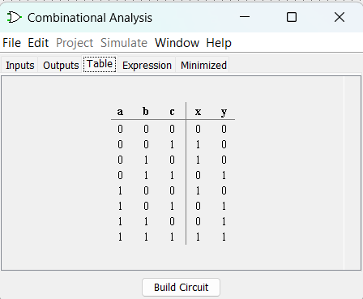

 Sum=(A⊕B) ⊕Cin

Carry=A.B+ (A ⊕B)

Logical Diagram:

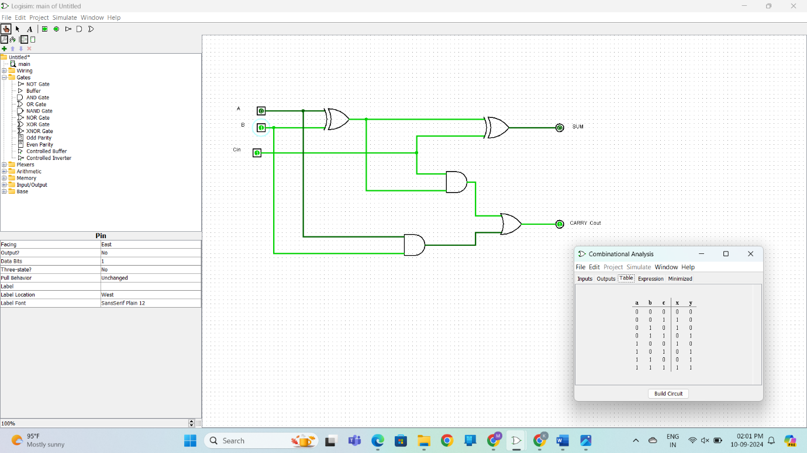

Full adder using NAND Gates:

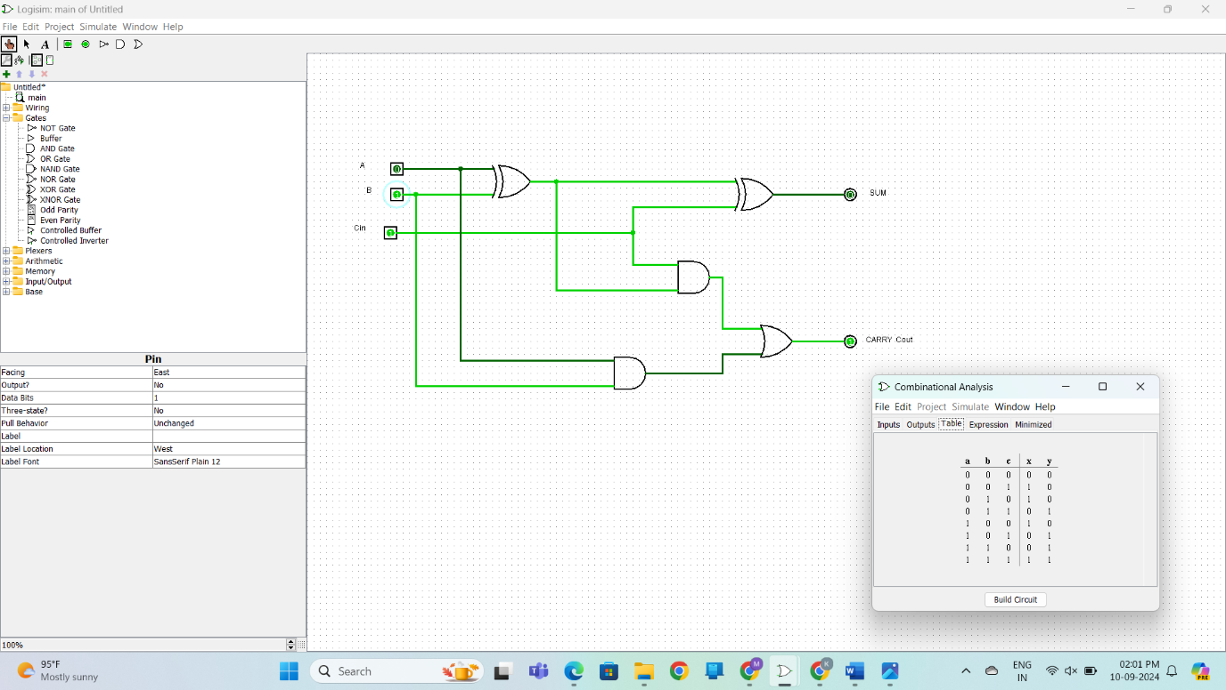

Full adder using NOR Gates:

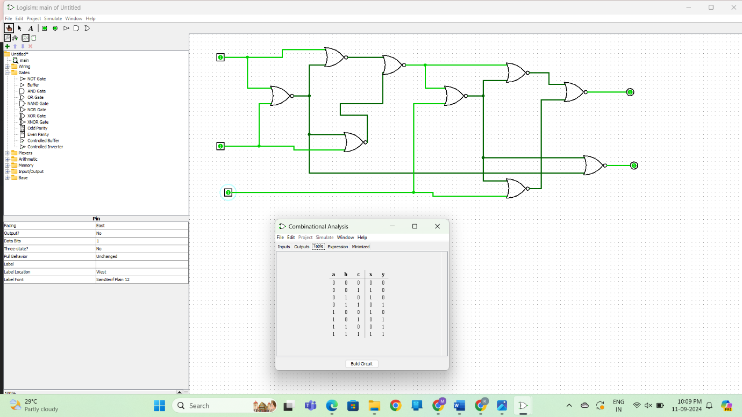

OUTPUT

RESULT: Thus full adder has been designed and implemented successfully using logisim

simulator.